**Install latest version of MongoDB from apt-get repository**

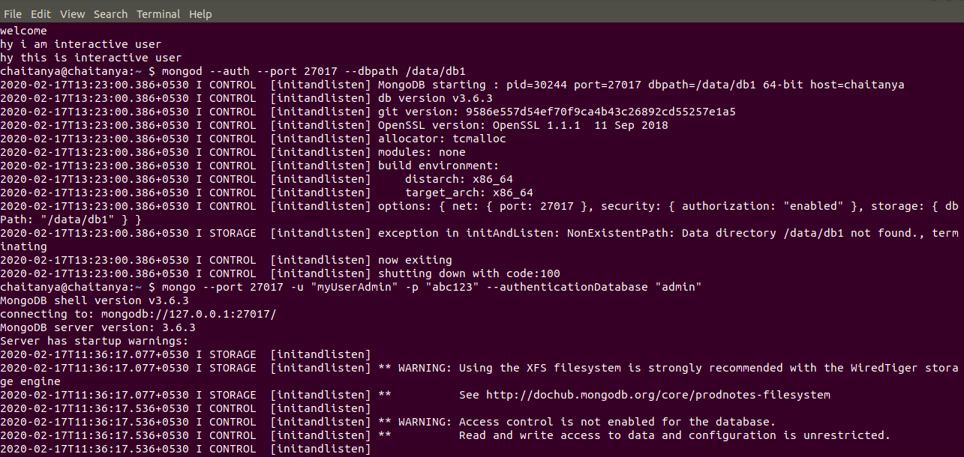

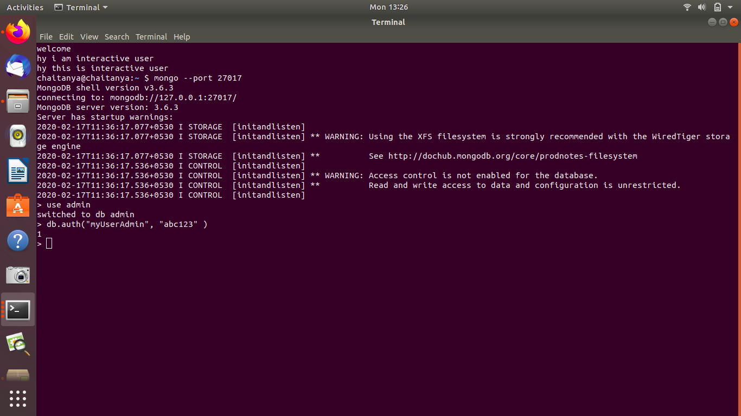

**Create a database student**

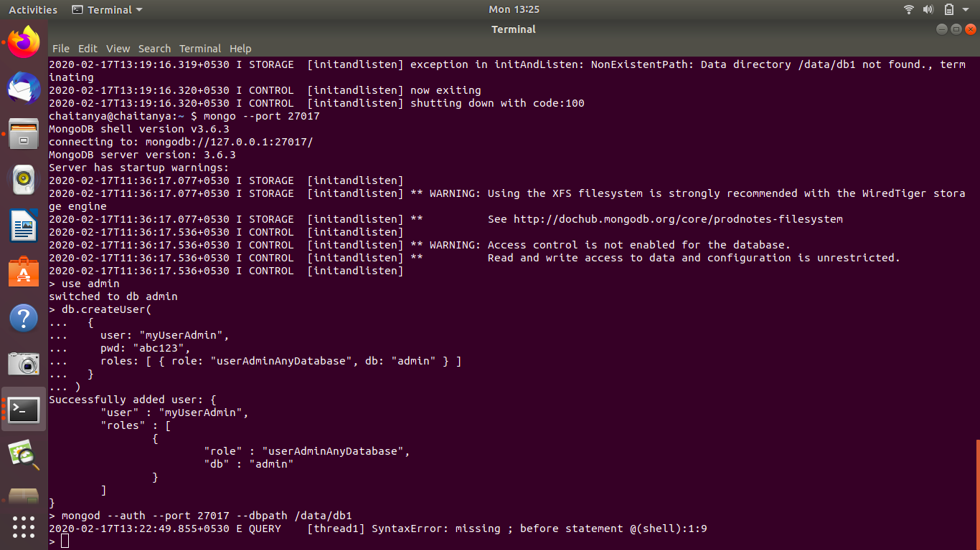

**Insert operation : 5 students data (Name, Contact, City, Roll No, Branch)**

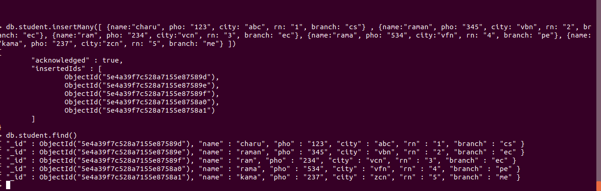



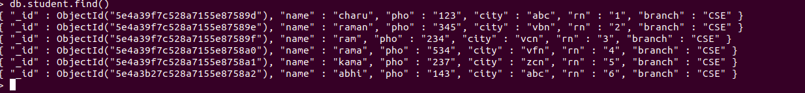

**Read operation : All the students belong to a particular city**



**Update operation : Update the branch of all the students to CSE**

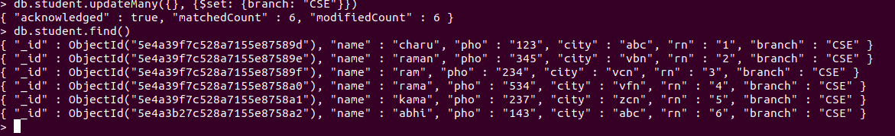

**Take dump of the database**

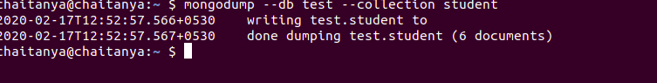

**Delete operation : Delete the record of last 2 students according to the roll number**

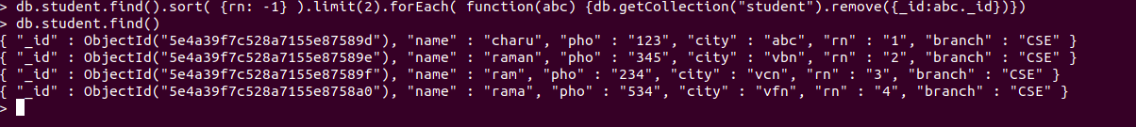

**Drop the database**

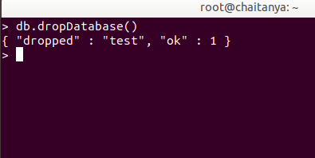

**Restore the database again to have the full data**

